Steps in building a LabView application

- Go to tools, build application or shared library. Give your exe a name.
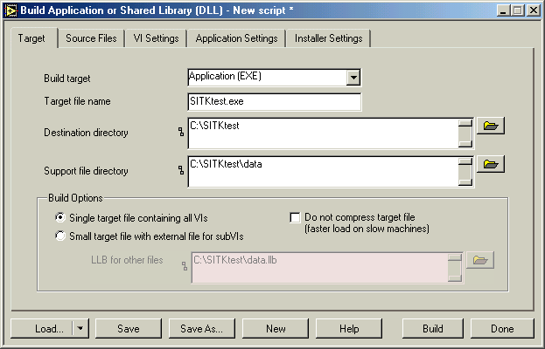

- Go to the source files tab and select your main VI with “add top-level VI”
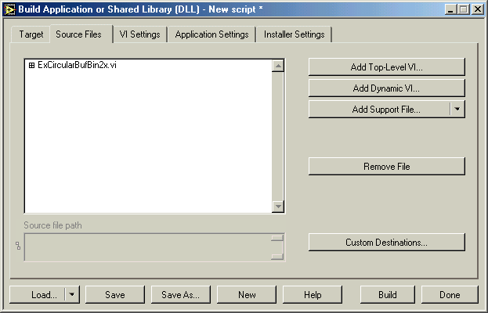

- Then select Build at bottom of the dialog.
- You should now have a exe, you still have to copy all the SITK® dlls, r3x, and ini files, as well as the Roper DLLs and dat files into the same directory as your exe.
- Finally copy over the real time license into that directory.

Then double click on the exe and you should be up and running.

